**Case example**

In the following, we use a case example of a sports center application to illustrate the use of our DSL. In this context, Figure 1 presents an extract of the database schema of this application, highlighting the main entities and their relationships. Figure 2 describes specific processing that is performed by the application.

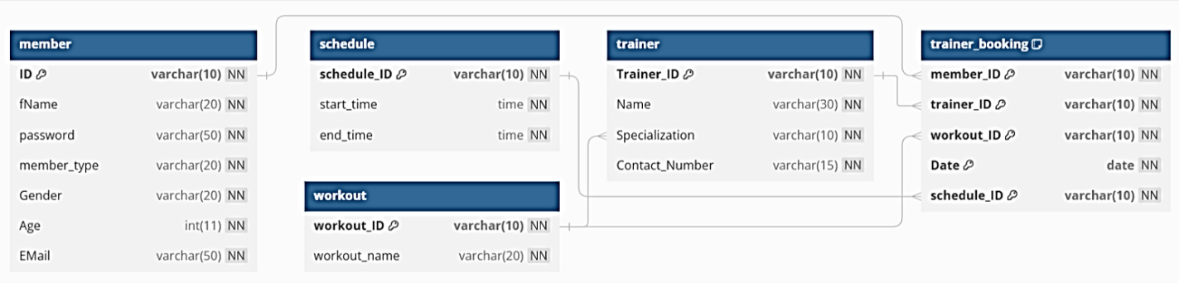

Figure 1 Except class diagram sport center

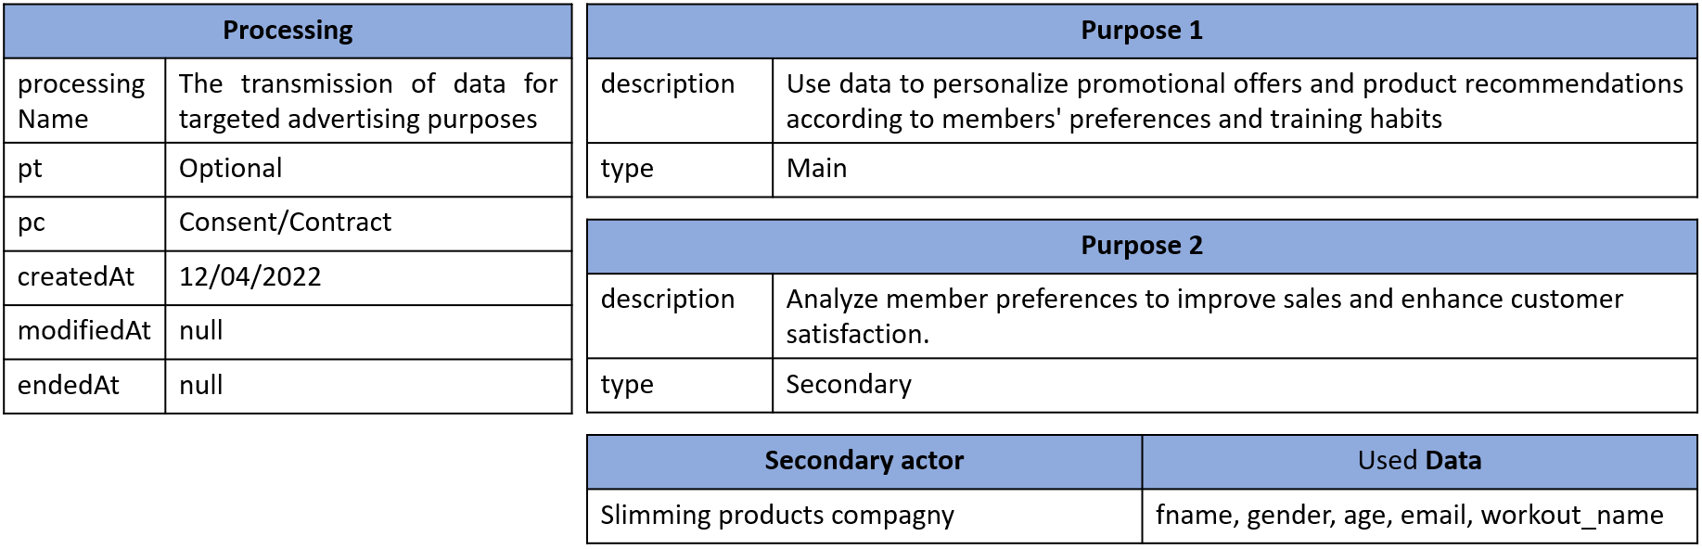

Figure 2 Processing description example

**1.Annotation**

**1.1 Actors**

The aim of using the DSL is to generate artifacts from the annotation (user stories, comic creation script and instantiation script) that will help the developer to integrate privacy easier.

Figure 3 illustrates an example of actor annotation. This involves specifying the contact details of the application owner, the DPO (if applicable), supervisory authority, the categories of data subjects, etc.

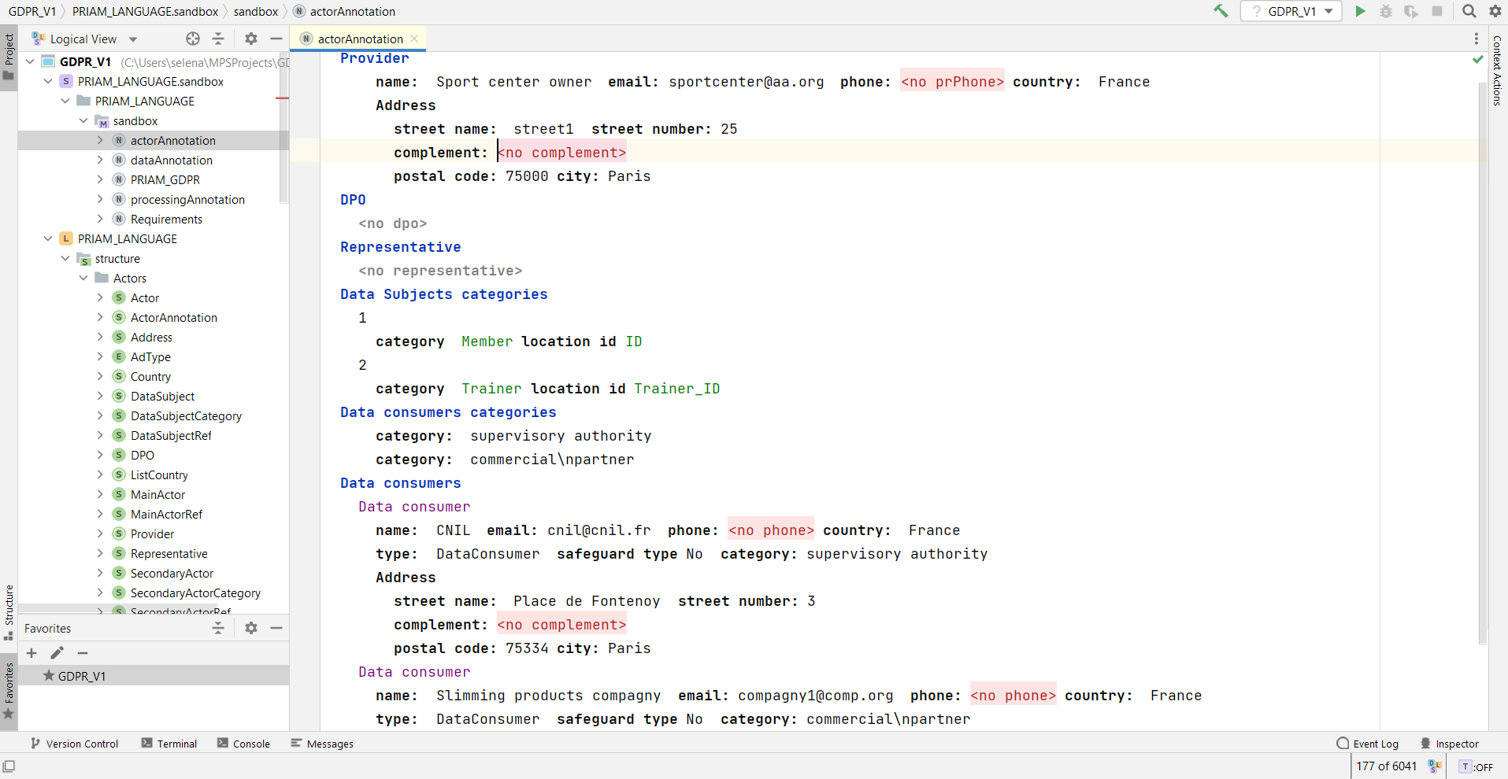

Figure 3 Example of actors annotation

**1.2 Data**

In this step, the application owner annotates all the data contained in his application. For each piece of data, he specifies its source, its retention period, its category, its status (personal/non-personal) and the data subject category to which it belongs. Figures 4 and 5 show an example of the annotation of data contained in the member, workout and trainer tables.

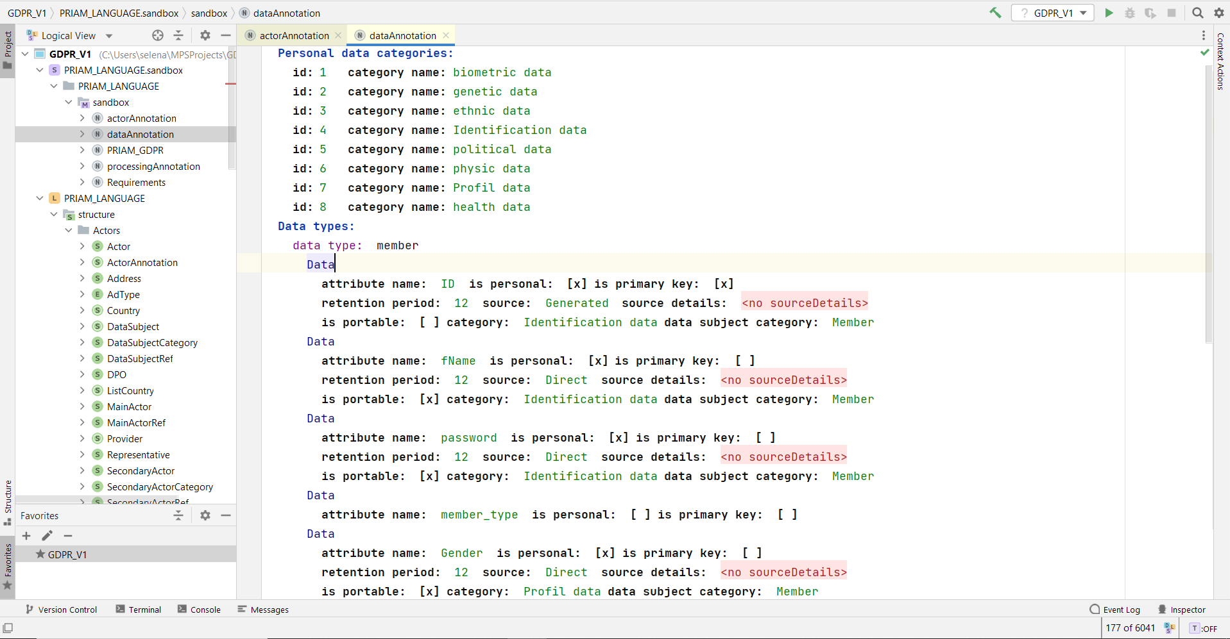

Figure 4 Example of data annotation

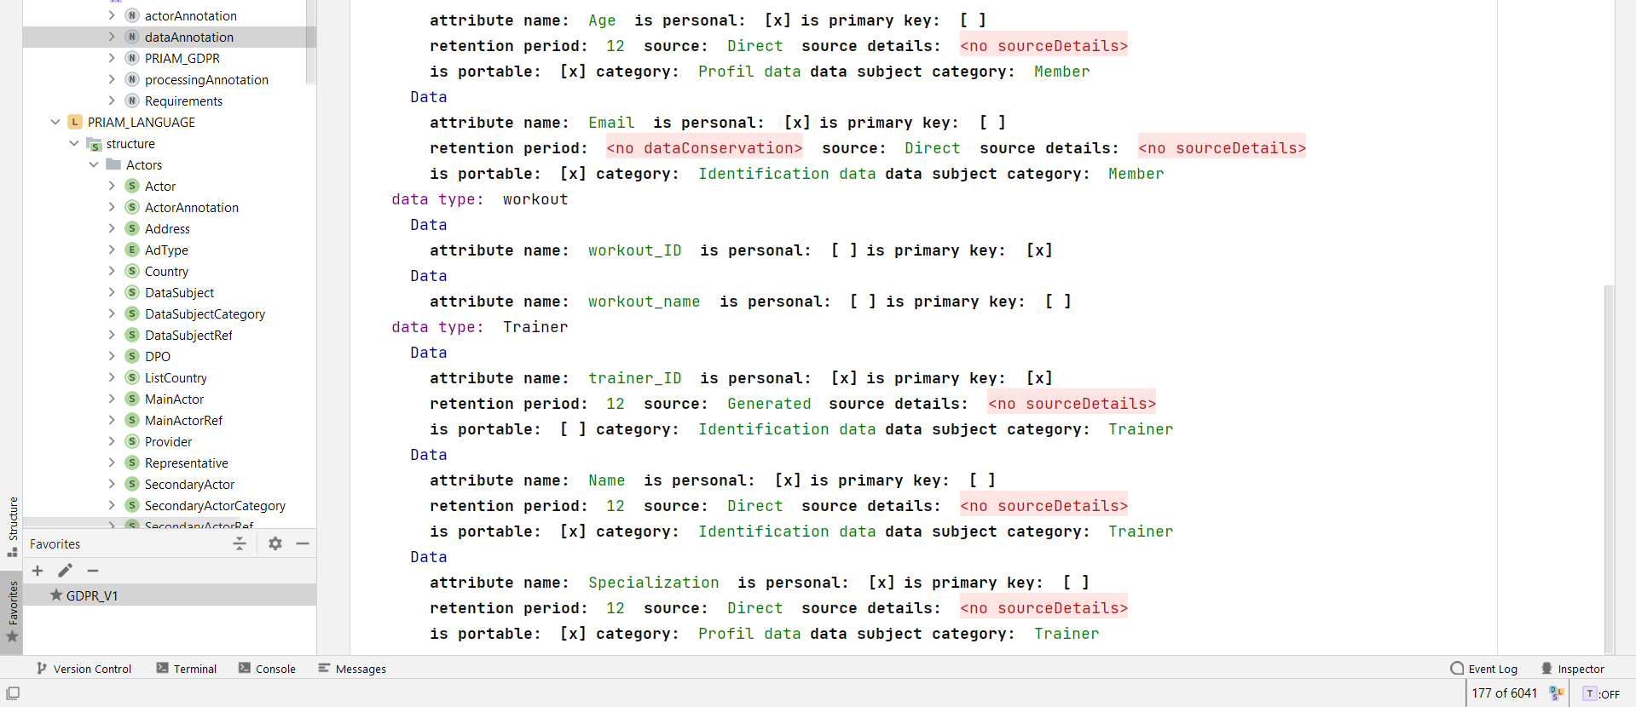

Figure 5 Example of data annotation (continued)

**1.3 Processings**

Similarly, processings are annotated. A detailed description of each one is necessary to ensure privacy management (see example in figure 6).

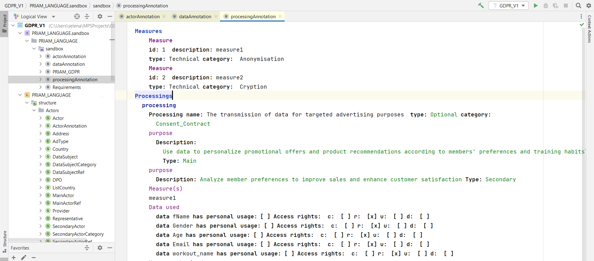

Figure 6 Example of processing annotation

**2. Automatic generation of artifacts**

Once the annotation has been made, the DSL generate :

1. A creation script for the PRIAM DB.Script d’instanciation,
2. The instantiation script that allows populate PRIAM database with application-specific privacy enforcement data such as the list of processings *(see figure 7),*
3. A set of specific user stories *(see figure 8).*

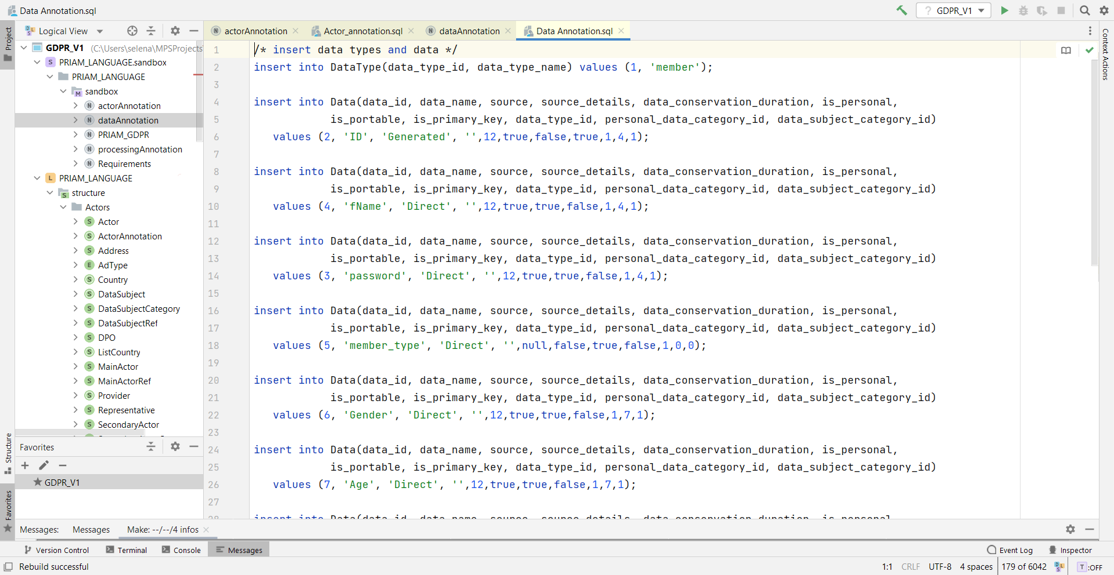

Figure 7 Preview of the generated instantiation script

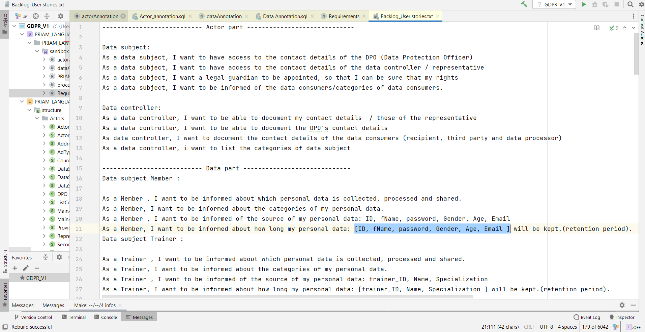

Figure 8 Preview of the generated user stories (except)

**Note :** As shown in Figure 9, scripts and user stories are generated as files with .sql and .text extensions, respectively.

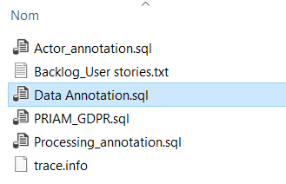

Figure 9 Generated files by the DSL